

Mini Project Report - 04
Master of Computer Application
Semester – I

Sub: Front-End Framework and Technologies
Topic: Semantic Dep Website
By
Name: M.Sanjana
Reg no. : PROV/ASAC/MCA/7/26/077

Faculty Name: Veera Raghav Kathula

Faculty Signature: _______________
Department of Computer Application
Alliance University
Chandapura - Anekal Main Road, Anekal
Bengaluru - 562 106
August 2026

INDEX
SL. NO | NAME OF TOPIC | PG NO
1 | INTRODUCTION | 2
2 | INPUT CODE | 3-7
3 | OUTPUT CODE | 8-9
4 | CONCLUSION | 10

INTRODUCTION
The MCA Department webpage is designed to provide information about the Master of Computer Applications program. It includes details about the department, faculty, courses, timetable, achievements, events, and contact information. HTML is used to create the structure of the webpage, while CSS is used to style the headings, navigation bar, images, sections, and other elements. The webpage also uses internal links to navigate between different sections.

INPUT CODE

<html>
<head>
<title>MCA Department</title>
<style>
* {
margin: 0;
padding: 0;
}

nav {
display: flex;
justify-content: space-around;
}

h1 {
text-align: center;
padding: 5px;
font-family: sans-serif;
text-shadow: 2px 4px 6px rgb(219, 216, 216);
}

header {
background: rgb(121, 160, 59);
padding-bottom: 10px;
}

nav a {
color: aliceblue;
margin-top: 10px;
text-decoration: none;
}

nav a:hover {
color: yellow;
}

section {
padding: 30px;
min-height: 250px;
}

h2 {
text-align: center;
margin-top: 10px;
font-size: 25px;
font-family: monospace;
color: rgb(211, 155, 51);
text-shadow: 2px 4px 6px gray;
}

h3 {
text-align: center;
margin: 20px;
}

p {
margin-top: 20px;
line-height: 1.6;
}

article {
text-align: center;
}

img {
height: 200px;
width: 200px;
margin: 20px;
border-radius: 20px;
border: 2px solid black;
box-shadow: 4px 8px 16px black;
}

.box {
display: flex;
justify-content: center;
gap: 80px;
}

hr {
border: 1px solid gray;
}
</style>
</head>
<body>

<header>
<h1>MCA Department</h1>

<nav>
<a href="#home">Home</a>
<a href="#about">About</a>
<a href="#faculty">Faculty</a>
<a href="#courses">Courses</a>
<a href="#timetable">TimeTable</a>
<a href="#achievements">Achievements</a>
<a href="#events">Events</a>
<a href="#contact">Contact</a>
</nav>
</header>

<section id="home">

<p>
MCA is a postgraduate academic degree that focuses on advanced
theoretical and practical knowledge of computer application development.
Graduates are highly sought after worldwide by tech companies,
financial institutions, and government agencies for software engineering roles.
</p>

<marquee>
<h2>Dear MCA Graduate, Welcome</h2>
</marquee>

<h3>Highlights</h3>

<article>
<img src="./AI.jpg" alt="Generative AI">
<img src="./datascience.jpg" alt="Game Development">
<img src="./datascience.jpg" alt="Data Science">

<div class="box">
<p>GEN AI</p>
<p>Game Development</p>
<p>Data Science</p>
</div>
</article>

</section>

<hr>

<section id="about">
<h2>About MCA Department</h2>

<p>
The Master of Computer Applications (MCA) department provides
students with knowledge and practical skills in computer science,
programming, software development and emerging technologies.
The department focuses on developing technical and problem-solving
abilities required for successful careers in the IT industry.
</p>
</section>

<hr>

<section id="faculty">
<h2>Faculty</h2>

<p>
Our department has experienced and dedicated faculty members
who guide students in academics, projects, research and technical
activities.
</p>

<p>
<b>Dr. Anitha Kumar</b> - Head of Department<br>
<b>Prof. Ravi Kumar</b> - Assistant Professor<br>
<b>Prof. Priya Sharma</b> - Assistant Professor
</p>
</section>

<hr>

<section id="courses">
<h2>Courses</h2>

<p>
* Python Programming<br>
* Data Structures<br>
* Database Management System<br>
* Web Development<br>
* Artificial Intelligence<br>
* Machine Learning<br>
* Data Science<br>
* Cloud Computing
</p>
</section>

<hr>

<section id="timetable">
<h2>TimeTable</h2>

<p>
Monday - Python Programming<br>
Tuesday - Data Structures<br>
Wednesday - Database Management<br>
Thursday - Web Development<br>
Friday - Specialization (GenAI, Data Science, Gaming)
</p>
</section>

<hr>

<section id="achievements">
<h2>Achievements</h2>

<p>
Our MCA students have participated in various technical events,
coding competitions, hackathons, workshops and project exhibitions.
Students have also achieved excellent results in academics and
technical competitions.
</p>
</section>

<hr>

<section id="events">
<h2>Events</h2>

<p>
* Technical Workshops<br>
* Coding Competitions<br>
* Hackathons<br>
* Project Exhibition<br>
* Guest Lectures<br>
* Cultural Events
</p>
</section>

<hr>

<section id="contact">
<h2>Contact Us</h2>

<p>
MCA Department<br>
Computer Science Department<br>
Email: mca@college.com<br>
Phone: +91 9876543210
</p>
</section>

</body>
</html>
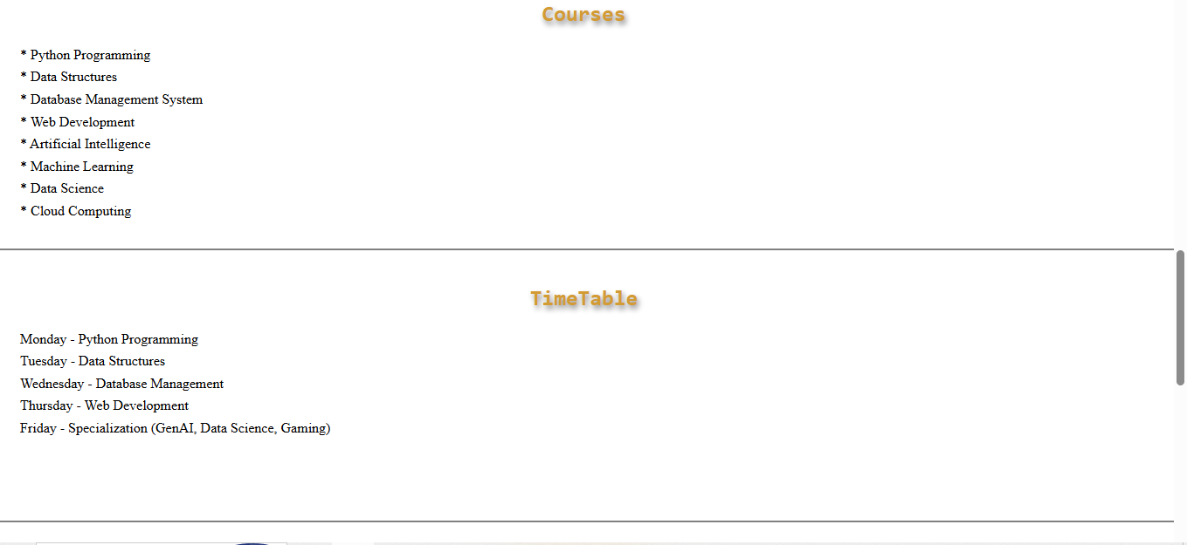
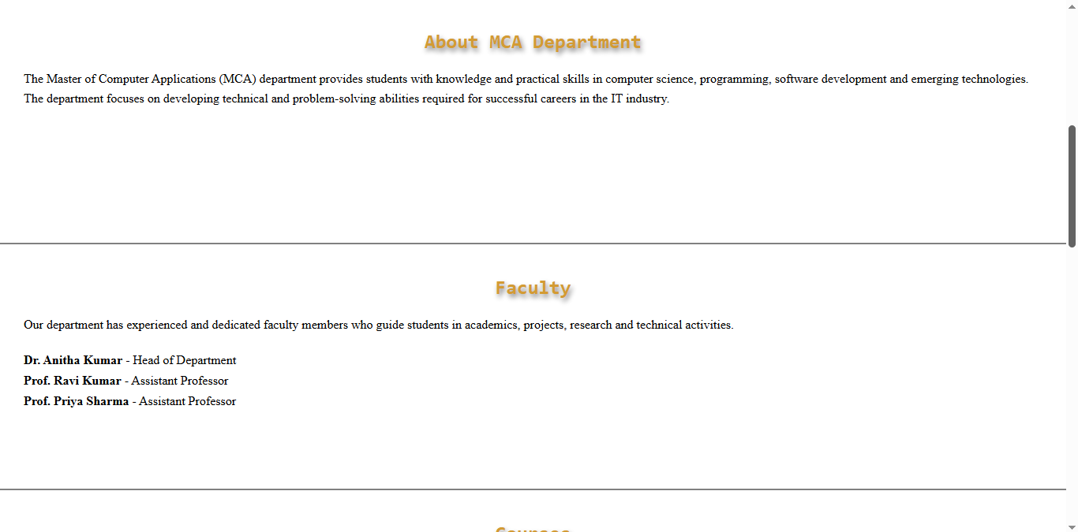
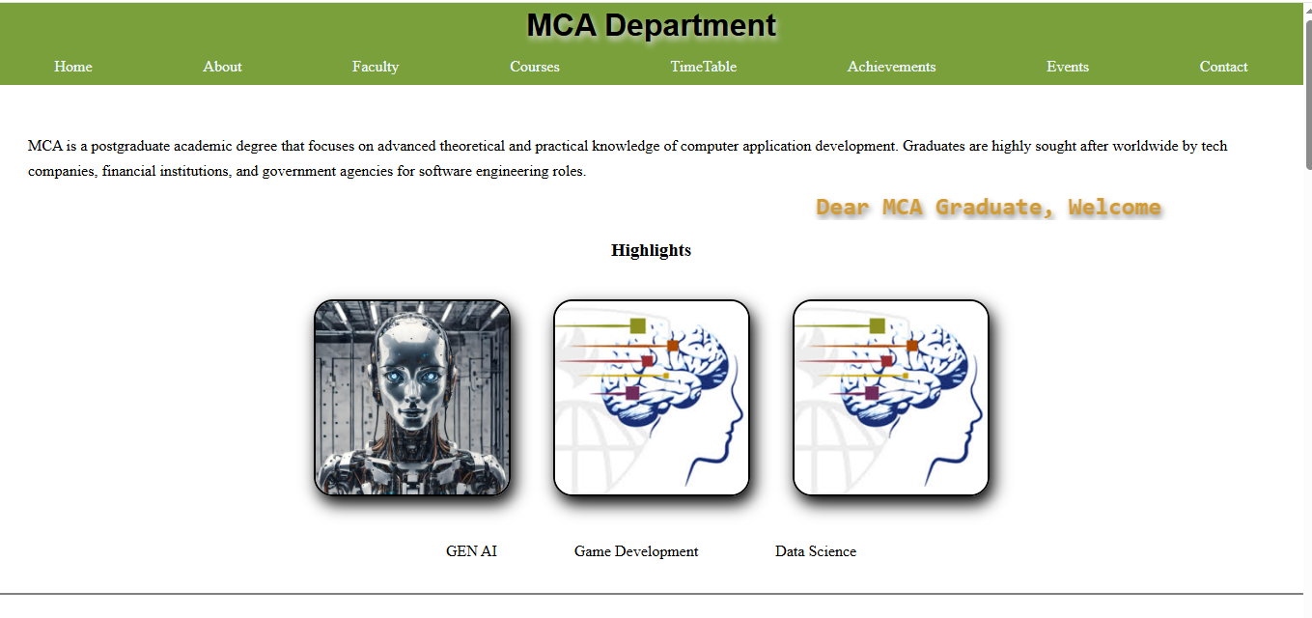
OUTPUT

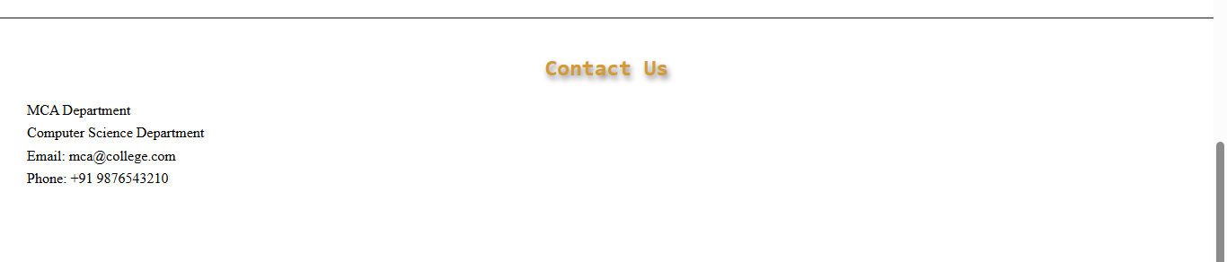
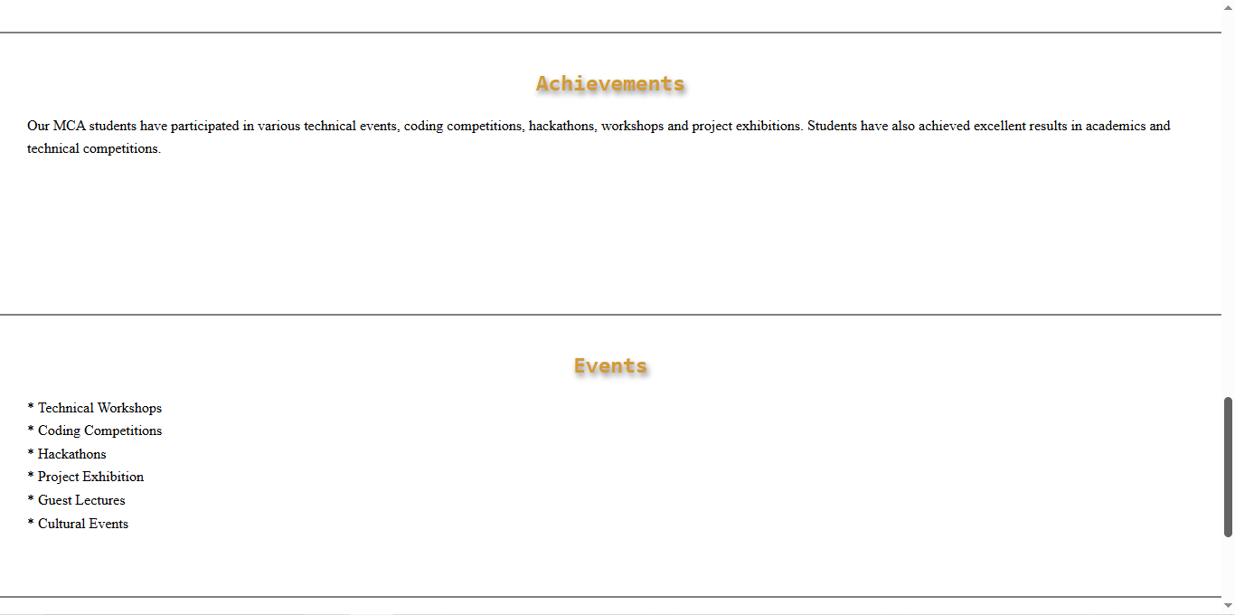

CONCLUSION
The MCA Department webpage successfully presents important information about the department in a simple and organized manner. HTML and CSS are used to create an attractive, user-friendly, and well-structured webpage. The navigation links, images, headings, and different sections make the webpage easy to understand and navigate.

